Odyssey Card Preview: Elephant Ambush and Beast Attack
Gary Wise
Combat should be easy. If you have a creature with a power greater than zero and your opponent has no creatures, you attack. If you have a 2/2 and your opponent has a 1/1, you attack. If you have a 2/2 and your opponent has a 3/3, you hold your creature back to fight another day. Easy.
The reason that combat seems simple is because everything is sitting there in plain sight. It isn't like a counter war, where you can only approximate what your opponent has in their hand or deck; you know what's on the table and whether that entity can safely block or not. Such simplicity gives us security; it's nice to know that things can be as they seem.
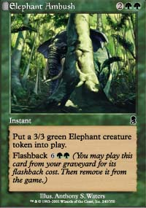
Unfortunately, if any of this seems familiar, you aren't going to like the little wrench Odyssey's green is throwing your way. Simian Grunts set the standard as far as instant-speed creatures go a few years ago, but that was just one creature in an expansion. In other words, the presence of the Grunts wasn't enough to make the potential attacker think twice, it was just an annoying reality one knew they could be running a creature into.
With Odyssey though, it's going to be different. Imagine, if you will, drafting three packs of Odyssey and facing the green deck which plays that fifth land and says go without casting anything on turn five. Now you have to consider the fact that not only is there an extremely powerful uncommon, Beast Attack, that will produce a 4/4 token creature on command, but also that there's an equally powerful common, Elephant Ambush, that similarly produces a 3/3 token. Do you really want to attack with your Atog? Probably not.
The pairing of Elephant Ambush and Beast Attack in Odyssey makes attacking with lesser creatures dangerous. No longer will recklessly attacking with whatever happens to be available be the only option. R&D is sending out a message: Treat that with value as if it has value. You never know when your powerful 1/1 utility creature is going to get eaten alive by an instant green fatty.
As if the possibility of killing off creatures with green instants wasn't enticing enough, now you have to look at the after effect. Not only do you have a strong possibility of killing an attacking creature, but you also get to keep the token creature in play after the fact. Take it a step further, and later in the game you can recast either spell thanks to their flashback abilities.
That's a lot of card advantage right there. Kill an attacker as a fast effect, trade the token with an opposing creature or two, recast it (again as an instant) and trade it again. Now, throw in the fact that you can use the instant speed of both spells to create an additional attacker at the end of your opponent's turn and you have two cards that gain card advantage, attack for massive amounts of damage and throw off opposing math. Green anyone?
Now, obviously this all adds up to two great Limited cards, but the big question is will either one see play in competitive Constructed formats (assuming of course that every card eventually sees play in non-competitive formats, right Anthony?), and for the answer we look at recent history.
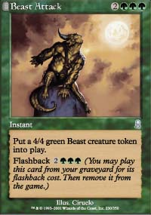
The last two Pro Tour-Chicago tournaments provide us with examples that suggest that the future could see play for one of these cards, more likely Beast Attack than Elephant Ambush due to the cost of the Ambush's flashback. Simian Grunts saw their way into the deck played by Adrian Sullivan and Mike Flores in 1999, with the combination of size, speed and potential for card advantage making the big monkey the right call for the deck. Meanwhile, last Chicago's Standard format featured an environment that was full of creatures, with either the Attack or Ambush certainly proving capable of taking an opposing critter out and leaving both incarnations of the spell behind.
One deck that Beast Attack could be especially interesting in is Extended Trinity. With five mana on turn three a regular occurrence, the 4/4 instant speed creature could make for an interesting choice in a blue-heavy environment where Submerge is the card of choice over Hibernation. The fact it's an instant would force opponent's to tap crucial mana, allowing the casting of important sorceries on your own turn, while circumventing Nevinyrral's Disk in much the same way a Penumbra creature would. Could make for an interesting metagame call.
While I wouldn't expect either card to see too much play in Extended or Standard, either one seems like it could be a viable choice in Odyssey block, with the combination of force and card advantage a good one when judging the viability of cards in a format whose limited card quantities set a lower bar of acceptability. Regardless, Beast Attack and Elephant Ambush are both by themselves and combined a force to be reckoned with. Odyssey looks like it'll be far from easy: would you have it any other way?

